PALM SUNDAY
APRIL 10, 2022

10:00 am service

Blessed is the One who comes in the name of the LORD,

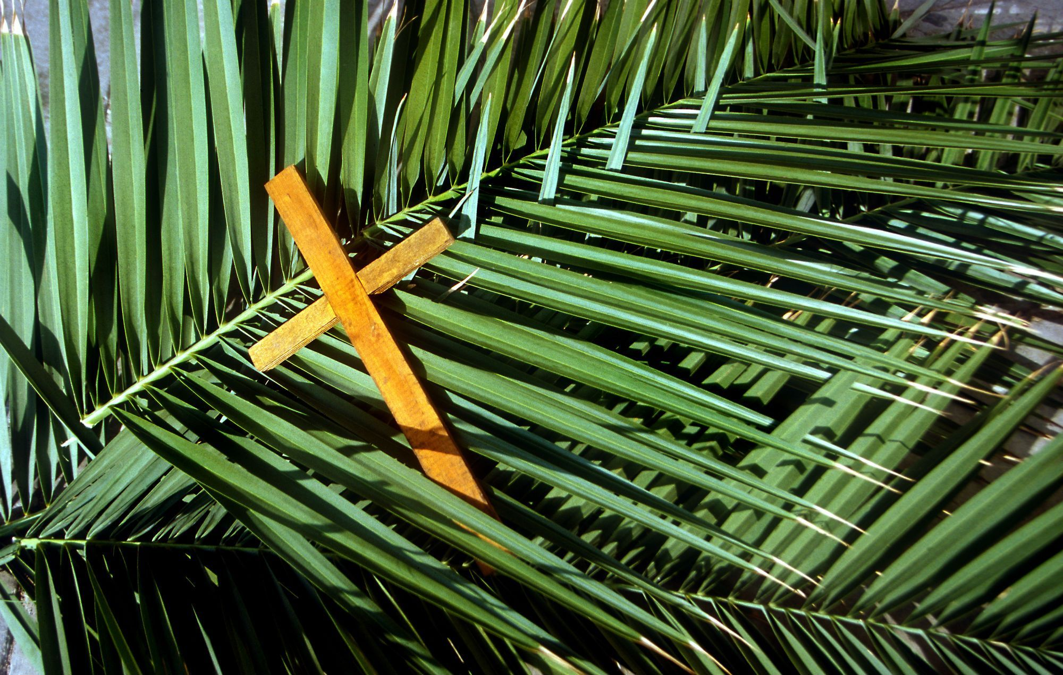

Hosanna in the highest.

Compelled by God's boundless love, we welcome people from all walks of life. We practice a faith that is rooted in Scripture, the traditions of the Episcopal Church, and a deep commitment to a loving community.

ST. BARTHOLOMEW’S EPISCOPAL CHURCH
678 Enos Way, Livermore, CA 94551, (925) 447-3289
Email: saint.barts@att.net
Website: www.saintbartslivermore.com
Opening our doors wider!

The Rev. Andrew D. Lobban, Rector
The Rev. Jennifer Nelson, Deacon

Let our invitation be unmistakable:
All are welcome in this place!
THE WORD OF GOD
The Liturgy of the Palms (Scripture insert) will begin in the courtyard. We will then process into the Sanctuary.
Opening Hymn All glory, laud, and honor The Hymnal 1982 #154

Celebrant The Lord be with you.
People And also with you.
Celebrant Let us pray.
Almighty and everliving God, in your tender love for the human race you sent your Son our Savior Jesus Christ to take upon him our nature, and to suffer death upon the cross, giving us the example of his great humility: Mercifully grant that we may walk in the way of his suffering, and also share in his resurrection; through Jesus Christ our Lord, who lives and reigns with you and the Holy Spirit, one God, for ever and ever. Amen.

All are seated.

The Proclamation of the Word Please see Scripture Insert.

After each reading:
Reader The Word of the Lord.
People Thanks be to God.

All stand.

Hymn When I survey the wondrous Cross The Hymnal 1982 #474

All are seated until the Passion narrative reads “all stand.”

The Passion Gospel Scripture Insert

All are seated.

The Sermon

All stand.

The Prayers of the People

Leader In awe of the Paschal Mystery, let us pray, saying, "Lord, have mercy upon us."

After each petition, the congregation will respond “have mercy upon us.”

The Celebrant concludes with a Collect.

The Peace

Celebrant The peace of the Lord be always with you.
People And also with you.
The Ministers and People greet one another in the name of the Lord.

THE HOLY COMMUNION

All stand.
Celebrant The Lord be with you.
People And also with you.
Celebrant Lift up your hearts.
People We lift them to the Lord.
Celebrant Let us give thanks to the Lord our God.
People It is right to give him thanks and praise.
It is right, and a good and joyful thing, always and everywhere to give thanks to you, Father Almighty, Creator of heaven and earth…Therefore we praise you, joining our voices with Angels and Archangels and with all the company of heaven, who forever sing this hymn to proclaim the glory of your Name:
Sanctus The Hymnal 1982 #S-124
The Celebrant continues
Holy and gracious Father: In your infinite love you made us for yourself…Therefore we proclaim the mystery of faith:
Celebrant and People
Christ has died. Christ is risen. Christ will come again.

The Celebrant continues
We celebrate the memorial of our redemption, O Father…By him, and with him, and in him, in the unity of the Holy Spirit all honor and glory is yours, Almighty Father, now and forever. AMEN.

And now, as our Savior Christ has taught us, we are bold to say:
Our Father, who art in heaven, hallowed be thy Name. Thy kingdom come, they will be done, on earth as it is in heaven. Give us this day our daily bread. And forgive us our trespasses, as we forgive those who trespass against us. And lead us not into temptation, but deliver us from evil. For thine is the kingdom, and the power, and the glory, forever and ever. Amen
The Celebrant breaks the consecrated Bread.
Christ our Passover is sacrificed for us; Therefore let us keep the feast.
Distribution of Communion. All who desire to receive Christ are welcome at the Lord’s Table!
Hymn after Communion Ah, holy Jesus The Hymnal 1982 #158

Post Communion Prayer

Celebrant Let us pray.
Celebrant and People Almighty and everliving God, we thank you for feeding us with the spiritual food of the most precious Body and Blood of your Son our Savior Jesus Christ; and for assuring us in these holy mysteries that we are living members of the Body of your Son, and heirs of your eternal kingdom. And now, Father, send us out to do the work you have given us to do, to love and serve you as faithful witnesses of Christ our Lord. To him, to you, and to the Holy Spirit, be honor and glory, now and forever. Amen.

The Celebrant pronounces a blessing.
Closing Hymn O sacred head, sore wounded The Hymnal 1982 #168

The Dismissal

Deacon or Celebrant Go in peace to love and serve the Lord.
People Thanks be to God.

Organ postlude

