Holy Eucharist
The season after the Epiphany 2022

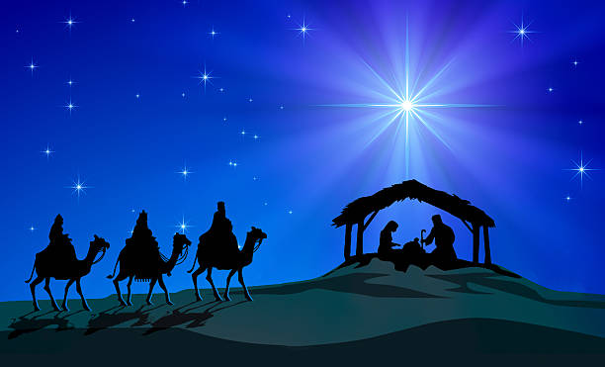

Compelled by God's boundless love, we welcome people from all walks of life. We practice a faith that is rooted in Scripture, the traditions of the Episcopal Church, and a deep commitment to a loving community.

ST. BARTHOLOMEW’S EPISCOPAL CHURCH
678 Enos Way, Livermore, CA 94551, (925) 447-3289
Email Address: saint.barts@att.net
Website: www.saintbartslivermore.com

The Rev. Andrew D. Lobban, Rector
The Rev. Jennifer Nelson, Deacon

Let our invitation be unmistakable:
All Are Welcome in This Place!

Musical prelude

THE WORD OF GOD

All stand.

Opening Hymn See announcements sheet or hymn boards

Celebrant Blessed be God: Father, Son, and Holy Spirit
People And blessed be his kingdom, now and forever. Amen.

The Celebrant says the Collect for Purity.

Song of Praise Glory to God in the highest The Hymnal 1982 #S-280

Celebrant The Lord be with you.
People And also with you.
Celebrant Let us pray.

The Celebrant prays the Collect of the Day.

People Amen

All are seated.

The Proclamation of the Word Please see Scripture Insert.
After each reading:
Reader The Word of the Lord.
People Thanks be to God.

All stand.

Sequence Hymn See announcements sheet or hymn boards

Minister The Holy Gospel of our Lord Jesus Christ according to ______.
People Glory to you, Lord Christ.

The Reader proclaims the Gospel.

Minister The Gospel of the Lord.
People Praise to you, Lord Christ.

All are seated.

The Sermon

All stand.

The Nicene Creed (said in unison)

Celebrant and People We believe in one God, the Father, the Almighty, maker of heaven and earth, of all that is, seen and unseen.

We believe in one Lord, Jesus Christ, the only Son of God, eternally begotten of the Father, God from God, Light from Light, true God from true God, begotten, not made, of one Being with the Father. Through him all things were made. For us and for our salvation he came down from heaven: by the power of the Holy Spirit he became incarnate from the Virgin Mary, and was made man. For our sake he was crucified under Pontius Pilate; he suffered death and was buried. On the third day he rose again in accordance with the Scriptures; he ascended into heaven and is seated at the right hand of the Father. He will come again in glory to judge the living and the dead, and his kingdom will have no end.
We believe in the Holy Spirit, the Lord, the giver of life, who proceeds from the Father and the Son. With the Father and the Son he is worshiped and glorified. He has spoken through the Prophets. We believe in one holy catholic and apostolic Church. We acknowledge one baptism for the forgiveness of sins. We look for the resurrection of the dead, and the life of the world to come. Amen.

The Prayers of the People

Leader With boundless joy in Christ’s Epiphany to all peoples, let us pray, saying, "O Christ of all the nations, hear our prayer."

After each petition, the congregation will respond “Hear our prayer.”
The Celebrant concludes with a collect.

The Confession of Sin

Minister Let us confess our sins against God and our neighbor
Minister and People Most merciful God, we confess that we have sinned against you in thought, word, and deed, by what we have done, and by what we have left undone. We have not loved you with our whole heart; we have not loved our neighbors as ourselves. We are truly sorry, and we humbly repent. For the sake of your Son Jesus Christ, have mercy on us and forgive us; that we may delight in your will, and walk in your ways, to the glory of your Name. Amen.
The Celebrant pronounces absolution.
The Peace
Celebrant The peace of the Lord be always with you.
People And also with you.

The Ministers and People greet one another in the name of the Lord.
Announcements and blessings of birthdays, anniversaries, and other significant life events.
All stand.

THE HOLY COMMUNION

Celebrant The Lord be with you.
People And also with you.
Celebrant Lift up your hearts.
People We lift them to the Lord
Celebrant Let us give thanks to the Lord our God.
People It is right to give him thanks and praise.

God of all power…glory and praise.
Glory to you forever and ever.

At your command…our island home.
By your will they were created and have their being.

From the primal elements…one another.
Have mercy, Lord, for we are sinners in your sight.

Again and again…freedom and peace.
By his blood he reconciled us. By his wounds we are healed.

And therefore we praise you…their unending hymn:

Sanctus Holy, Holy, Holy Lord The Hymnal 1982 #S-130

And so, Father…sacrifice of thanksgiving,
We celebrate his death and resurrection as we await the day of his coming.

Lord God of our Fathers…in his name.
Risen Lord, be known to us in the breaking of the Bread.

Accept these prayers and praises, Father…from generation to generation. AMEN.

And now, as our Savior Christ has taught us, we are bold to say:

Our Father, who art in heaven, hallowed be thy Name, thy kingdom come, thy will be done, on earth as it is in heaven. Give us this day our daily bread. And forgive us our trespasses, as we forgive those who trespass against us. And lead us not into temptation, but deliver us from evil. For thine is the kingdom, and the power, and the glory, for ever and ever. Amen.
The Celebrant breaks the consecrated Bread.

Celebrant Alleluia! Christ our Passover is sacrificed for us.
People Therefore let us keep the feast. Alleluia!

Distribution of Communion. All who desire to receive Christ are welcome at the Lord’s Table!

Post Communion Prayer

Celebrant Let us pray.

Celebrant and People
Almighty and everliving God, we thank you for feeding us with the spiritual food of the most precious Body and Blood of your Son our Savior Jesus Christ, and for assuring us in these holy mysteries that we are living members of the Body of your Son and heirs of your eternal kingdom. And now, Father, send us out to do the work you have given us to do, to love and serve you as faithful witnessed of Christ our Lord. To him, to you, and to the Holy Spirit, be honor and glory, now and forever. Amen.

The Celebrant pronounces a blessing.
Closing Hymn See announcements sheet or hymn boards

The Dismissal

Minister Let us go forth into the world, rejoicing in the power of the Spirit!
People Thanks be to God.
Musical postlude

