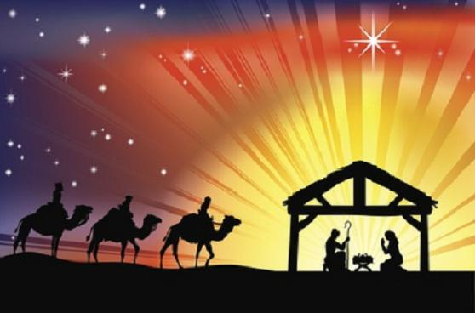
The season after Epiphany 2019 at St. Bartholomew’s Episcopal Church
Rite II Order of Service
 | Book of Common Prayer | The Hymnal 1982
THE WORD OF GOD
Opening hymn |  | See announcements
Opening acclamation | 355
Collect for purity | 355
Song of Praise (see music insert)
Collect of the Day | 357
First reading (see Scripture insert)
The Psalm (see Scripture insert)
Second reading (see Scripture insert)
Sequence hymn |  | See announcements
The Gospel (see Scripture insert) | 357-358
The Sermon
The Nicene Creed | 358
The Prayers of the People
The Confession of Sin | 359-360
The Peace | 360
THE HOLY COMMUNION
The Offertory-thank you for your generosity!
The Doxology |  | #380, v3
The Great Thanksgiving, Eucharistic Prayer C | 369
Holy, holy, holy Lord (see music insert)
The Lord’s Prayer | 364
The Breaking of the Bread | 364
The Communion-all who desire to receive the Presence of Christ are welcome! | 365
Communion hymn |  | See announcements
Post-communion prayer | 365
The Blessing
Closing hymn |  | See announcements
The Dismissal | 366
The season after Epiphany 2019 at St. Bartholomew’s Episcopal Church
Rite I Order of Service
 | Book of Common Prayer | The Hymnal 1982
THE WORD OF GOD
Opening hymn |  | See announcements
Opening acclamation | 323
Collect for purity and Great commandment | 323-324
Glory be to God on high |  | #S-204
Collect of the Day | 325
First reading (see Scripture insert)
The Psalm (see Scripture insert)
Second reading (see Scripture insert)
Sequence hymn |  | See announcements
The Gospel (see Scripture insert) | 326
The Sermon
The Nicene Creed | 326-327
The Prayers of the People | 328
The Confession of Sin | 330-331
The Peace | 332
THE HOLY COMMUNION
The Offertory-thank you for your generosity!
The Doxology |  | #380, v3
The Great Thanksgiving, Eucharistic Prayer I | 333
Holy, holy, holy Lord |  | #S-114
The Lord’s Prayer | 336
The Breaking of the Bread | 337
The Communion-all who desire to receive the Presence of Christ are welcome! | 338
Post-communion prayer | 339
The Blessing | 339
Closing hymn |  | See announcements
The Dismissal | 339-340

