The Holy Eucharist, 10:00 am, Sundays in summer
St. Bartholomew’s Episcopal Church

Order of Service adapted from A New Zealand Prayer Book

Instrumental prelude.

The Word of God

All stand for the opening hymn (see announcements sheet or hymn board).

Celebrant Blessed be God: Father, Son, and Holy Spirit.
People And blessed be God’s kingdom, now and forever. Amen.

The Celebrant says a Collect for Purity, then offers a Summary of the Law or A New Commandment.

All remain standing or kneeling for the following Confession.

Celebrant Let us confess our sins.
Celebrant and People Merciful God,
we have sinned
in what we have thought and said,
in the wrong we have done
and in the good we have not done.
We have sinned in ignorance:
we have sinned in weakness:
we have sinned through our own deliberate fault.
We are truly sorry.
We repent and turn to you.
Forgive us, for our Saviour Christ’s sake,
and renew our lives to the glory of your name. Amen.

The Celebrant pronounces absolution.

All stand and join in singing the Gloria.

My Heart Sings Out - #6 Glory to God
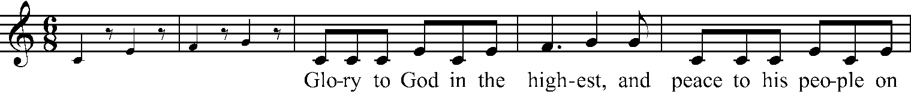
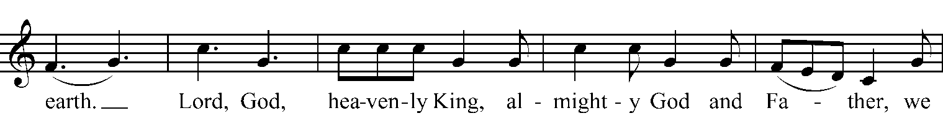
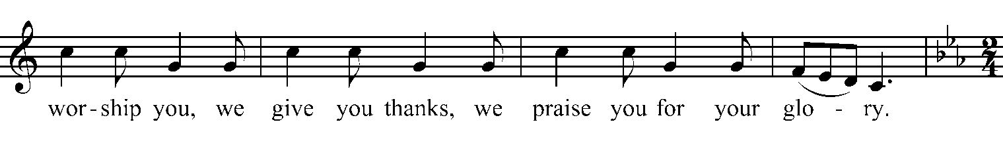
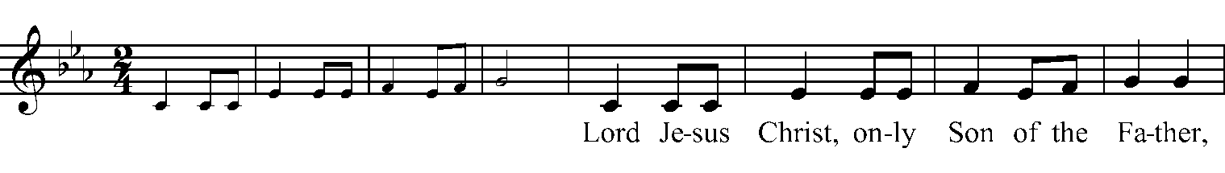
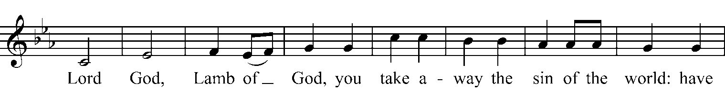
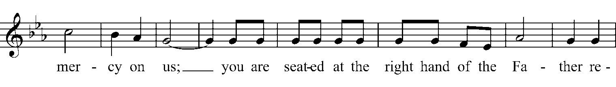
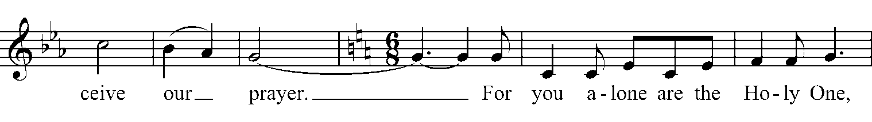
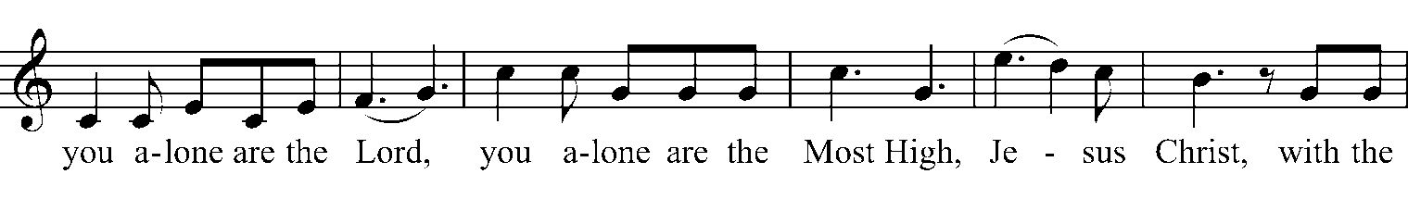
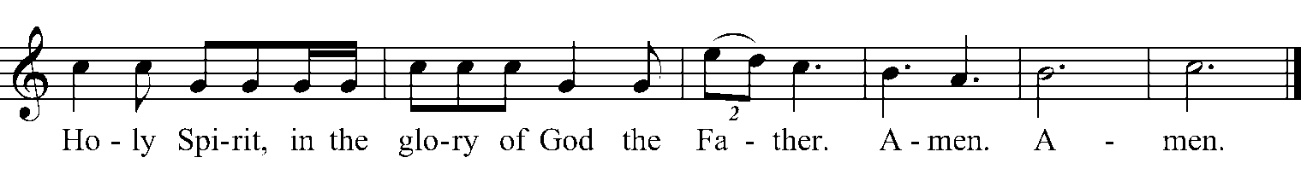

Celebrant May God be with you.
People And also with you.
Celebrant Let us pray.
The Celebrant prays the Collect for the Day.

All are now seated for the readings.

Readings are found in the insert. After each of the first two readings, the people respond: Thanks be to God.

All stand and join in singing the Alleluia three times.

My Heart Sings Out - #20 Celtic Alleluia
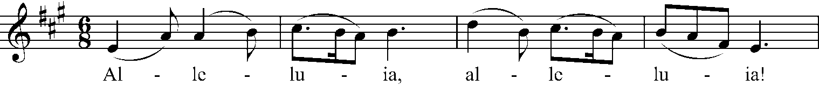
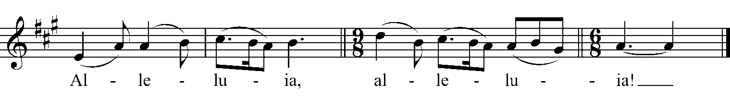
Deacon or Priest The Holy Gospel of our Lord Jesus Christ according to ___.
People Glory to you, Lord Christ.

The Deacon or Priest reads the Gospel.

Deacon or Priest The Gospel of the Lord.
People Praise to you, Lord Christ.

All are seated for the Sermon.

After the Sermon, all stand for the Affirmation of Faith:
We believe in one God, the Father, the Almighty,
maker of heaven and earth, of all that is, seen and unseen.

We believe in one Lord, Jesus Christ, the only Son of God,
eternally begotten of the Father,
God from God, Light from Light, true God from true God,
begotten, not made, of one being with the Father;
through him all things were made.
For us and for our salvation he came down from heaven,
was incarnate of the Holy Spirit and the Virgin Mary
and became fully human.
For our sake he was crucified under Pontius Pilate;
he suffered death and was buried.
On the third day he rose again in accordance with the Scriptures;
he ascended into heaven and is seated at the right hand of the Father.
He will come again in glory to judge the living and the dead,
and his kingdom will have no end.

We believe in the Holy Spirit, the Lord, the giver of life,
who proceeds from the Father and the Son,
who in unity with the Father and the Son is worshipped and glorified,
and has spoken through the prophets.

We believe in one holy catholic and apostolic Church.
We acknowledge one baptism for the forgiveness of sins.
We look for the resurrection of the dead,
and the life of the world to come. Amen.

All remain standing or kneeling for the Prayers of the People, after which the Celebrant says a concluding Collect.

Celebrant The peace of Christ be always with you.
People And also with you.

Please offer to one another a sign of peace.

All are then seated for announcements and greetings, as well as blessings and prayers for birthdays, anniversaries, and other special occasions.

The Holy Communion

The Celebrant says an Offertory Sentence, then an offering is taken for the ministries of St. Bartholomew’s. Thank you for your generosity!

All stand as the offerings are brought forward.

Celebrant The Lord is here.
People God’s Spirit is with us.
Celebrant Lift up your hearts.
People We lift them to the Lord.
Celebrant Let us give thanks to the Lord our God.
People It is right to offer thanks and praise.

The Celebrant continues: It is right indeed, it is our joy and our salvation, holy Lord,
almighty Father, everlasting God, at all times and in all places
to give you thanks and praise through Christ your only Son.
You are the source of all life and goodness;
through your eternal Word
you have created all things from the beginning
and formed us in your own image;
male and female you created us.
When we sinned and turned away
you called us back to yourself
and gave your Son to share our human nature.
By his death on the cross,
he made the one perfect sacrifice for the sin of the world
and freed us from the bondage of sin.
You raised him to life triumphant over death;
you exalted him in glory.
In him you have made us a holy people
by sending upon us your holy and lifegiving Spirit.
Therefore with the faithful who rest in him,
with angels and archangels and all the company of heaven,
we proclaim your great and glorious name,
forever praising you and singing:

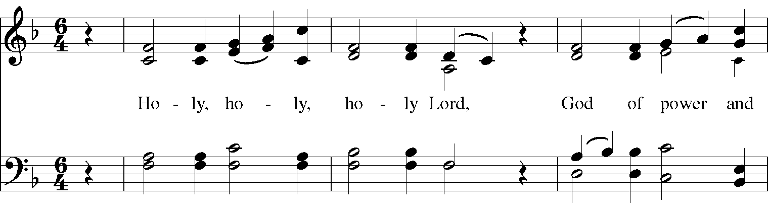
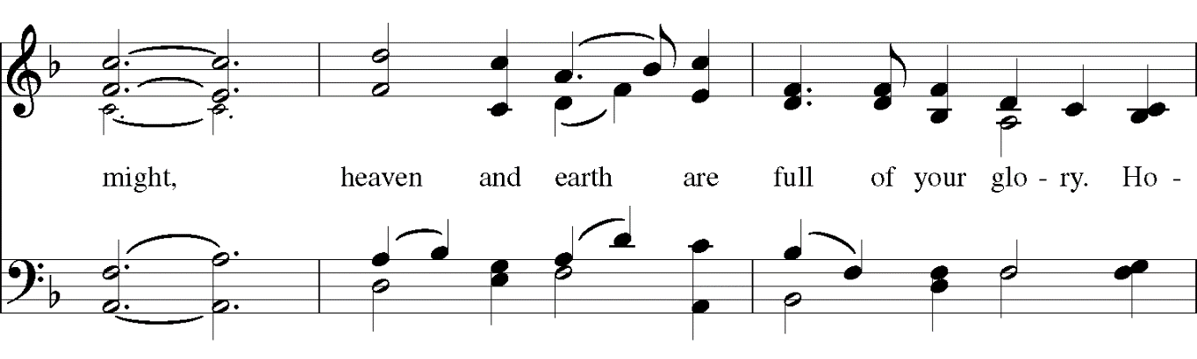
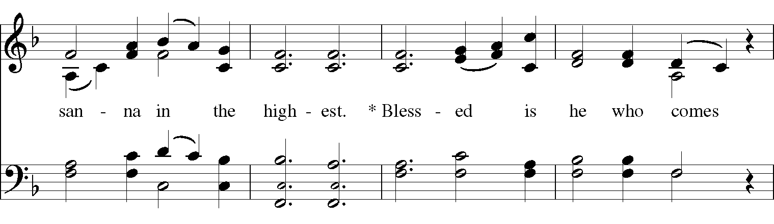
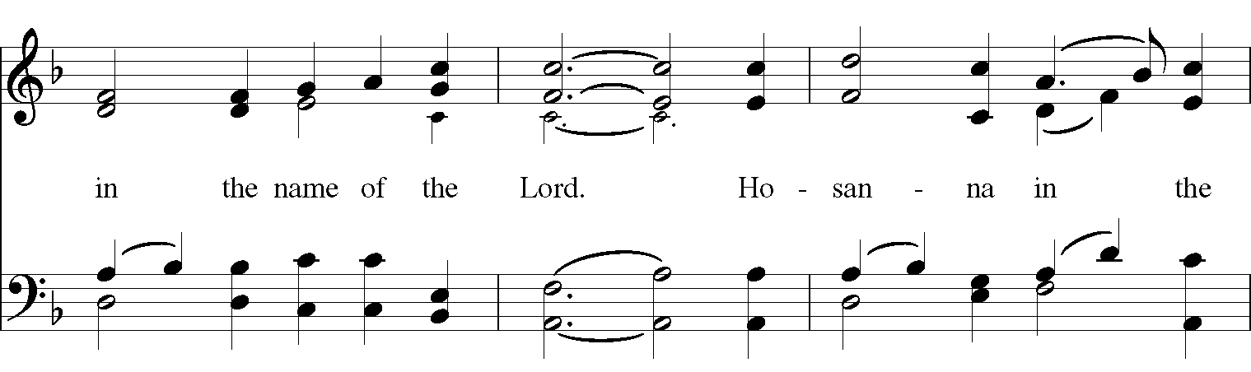
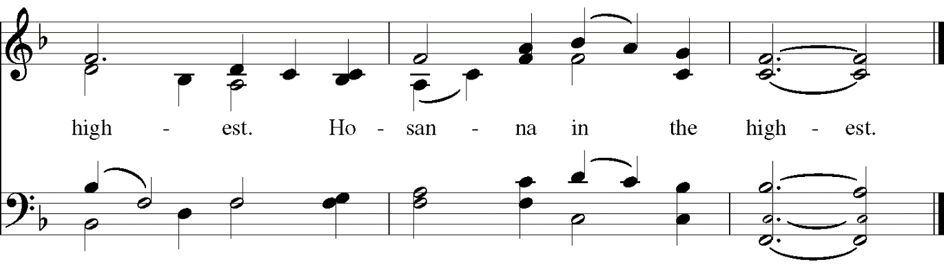
The Celebrant continues:
All glory and thanksgiving to you, holy Father; on the night before he died your Son, Jesus Christ, took bread; when he had given you thanks, he broke it, gave it to his disciples, and said:
Take, eat, this is my body which is given for you; do this to remember me.
After supper he took the cup; when he had given you thanks, he gave it to them and said:
Drink this, all of you, for this is my blood of the new covenant which is shed for you and for many for the forgiveness of sins; do this as often as you drink it, to remember me.

Celebrant and People:
Glory to you, Lord Christ;
your death we show forth;
your resurrection we proclaim;
your coming we await;
Amen! Come Lord Jesus.

The Celebrant continues:
Therefore loving God, recalling your great goodness to us in Christ, his suffering and death,
his resurrection and ascension, and looking for his coming in glory,
we celebrate our redemption with this bread of life and this cup of salvation.
Accept our sacrifice of praise and thanksgiving which we offer through Christ our great high priest.
Send your Holy Spirit that these gifts of bread and wine which we receive may be to us the body and blood of Christ, and that we, filled with the Spirit’s grace and power, may be renewed for the service of your kingdom.
United in Christ with all who stand before you in earth and heaven, we worship you, O God,
in songs of everlasting praise.

Celebrant and People:
Blessing, honour and glory be yours,
here and everywhere,
now and forever. Amen.

Celebrant: Now, as Christ teaches us, we pray.
Celebrant and People: Our Father in heaven, hallowed be your name,
your kingdom come, your will be done,
on earth as in heaven.
Give us today our daily bread.
Forgive us our sins as we forgive those who sin against us.
Save us from the time of trial
and deliver us from evil.
For the kingdom, the power, and the glory are yours
now and for ever. Amen.

The Celebrant breaks the consecrated bread. Silence is kept.

Celebrant We break this bread to share in the Body of Christ.
People We who are many are one body, for we all share the one bread.

The Celebrant invites the People to receive Communion. All who seek God and are drawn to Christ are welcome at the Communion table!

After all have received Communion, the Celebrant prays:
Father of all, we give you thanks and praise, that when we were still far off you met us in your Son and brought us home. Dying and living, he declared your love, gave us grace, and opened the gate of glory. May we who share Christ’s body live his risen life; we who drink his cup
bring life to others; we whom the Spirit lights give light to the world.

Celebrant and People:
Keep us firm in the hope you have set before us,
so we and all your children shall be free,
and the whole earth live to praise your name.

The Celebrant pronounces a blessing.

All join in the concluding hymn (see announcements sheet or hymn board).

Deacon or Priest Go now to love and serve the Lord.
People Amen. We go in the name of Christ.

Instrumental postlude.

